Roman Yushchyk

200368308

Computer Science 207

Creative technologies

Assignment 8

1. You have approximately 3 weeks to finish your projects. Reflect on as to whether or not your project is on schedule. What sort of set-backs have you had to put you behind?

My largest problem is shipping of my parts. I still missing a MP3 player and better LCD screen. Software wise mufriend.com rollout a new library update so I was able to gain control over my chip TFT touchscreen. Because I have to write my code from screech for different screen than was original project used I spent over 20 hours of solid coding practice to just draw a home screen and make sure I am on a point with every image or digit. Next step is to make a few more pages such a music player page, Alarm page and a paint notes page. I even add a new function call to a real-time clock library to make it work the way I want.

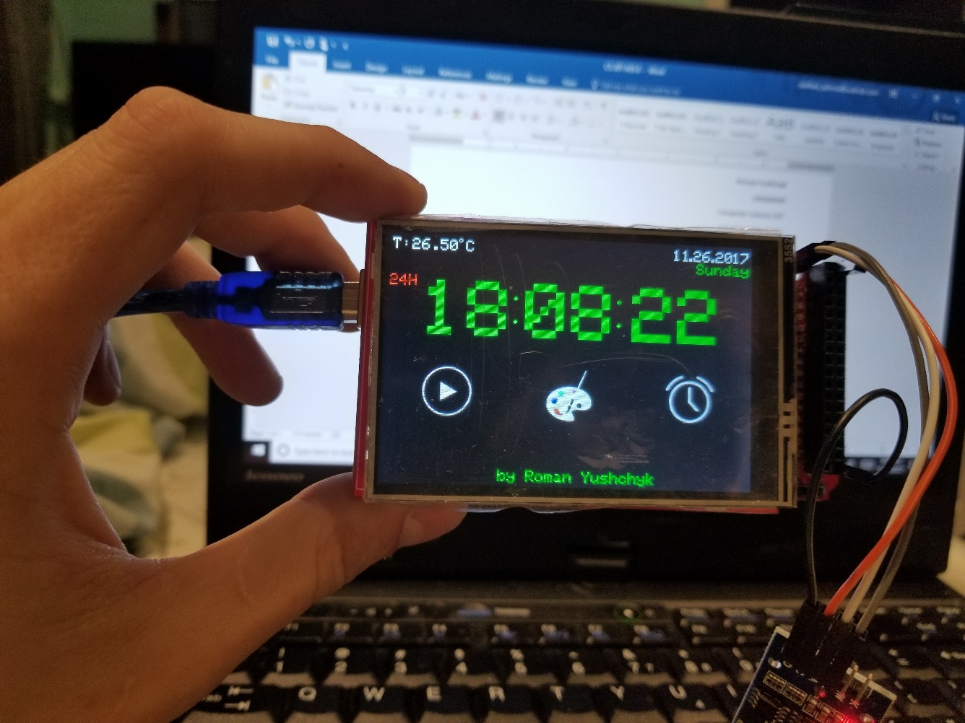

1. Draw a standard arduino-to-arduino I2C set-up.

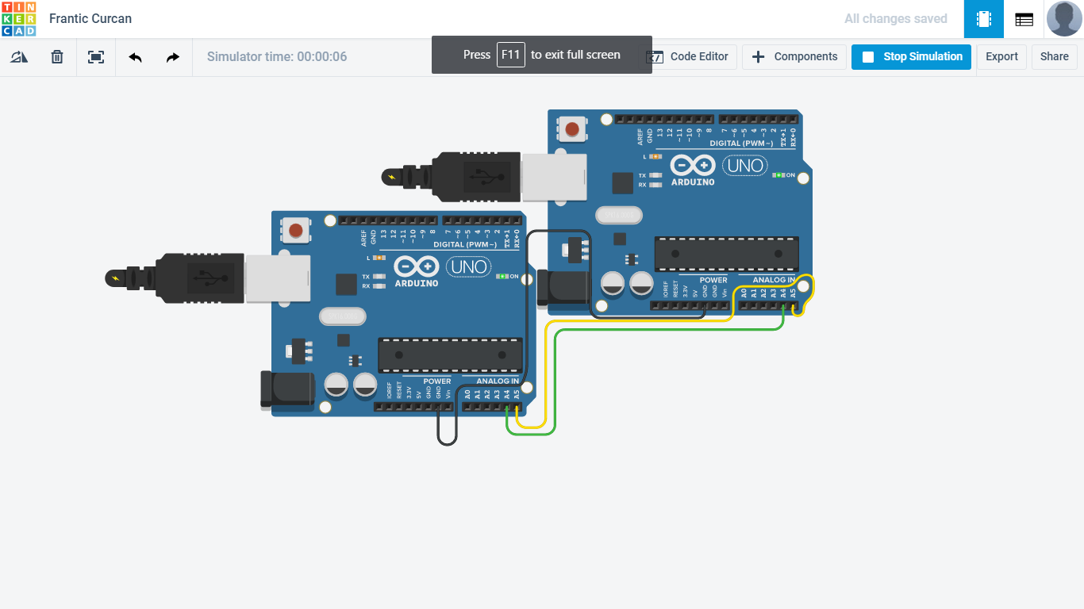

3) Choose and describe a wireless communication protocol discussed in class. What are the advantages and disadvantages of your protocol?

We have a wide selection of wireless protocols discussed in class.

­ Audio: **­ Audible ­ Ultrasonic ­ Subsonic ­ Example: chirp.io ­ Google tone**

­ Electromagnetic: **­ Visual light ­ Wifi ­ Bluetooth ­ RFID ­ NFC**

I choose NFC (Nearfield communication) as a wireless protocol to discuss.

Main advantage is a secure way to pay for your products without a wallet or open your home door. Because it requires very close proximity to work. Only an inch or two from the receiver. This makes it super hard for a third party to copy any information without being noticed.

Disadvantage is that despite its native security it is not protected as It should be on a software level. Considering that most tablets and phones comes with enabled NFC it is important to maintain an appropriate action to keep this protocol secure.